Python Assignment [19-12-2023]

by Karthikeyan K R

**Reading a data from csv file:**

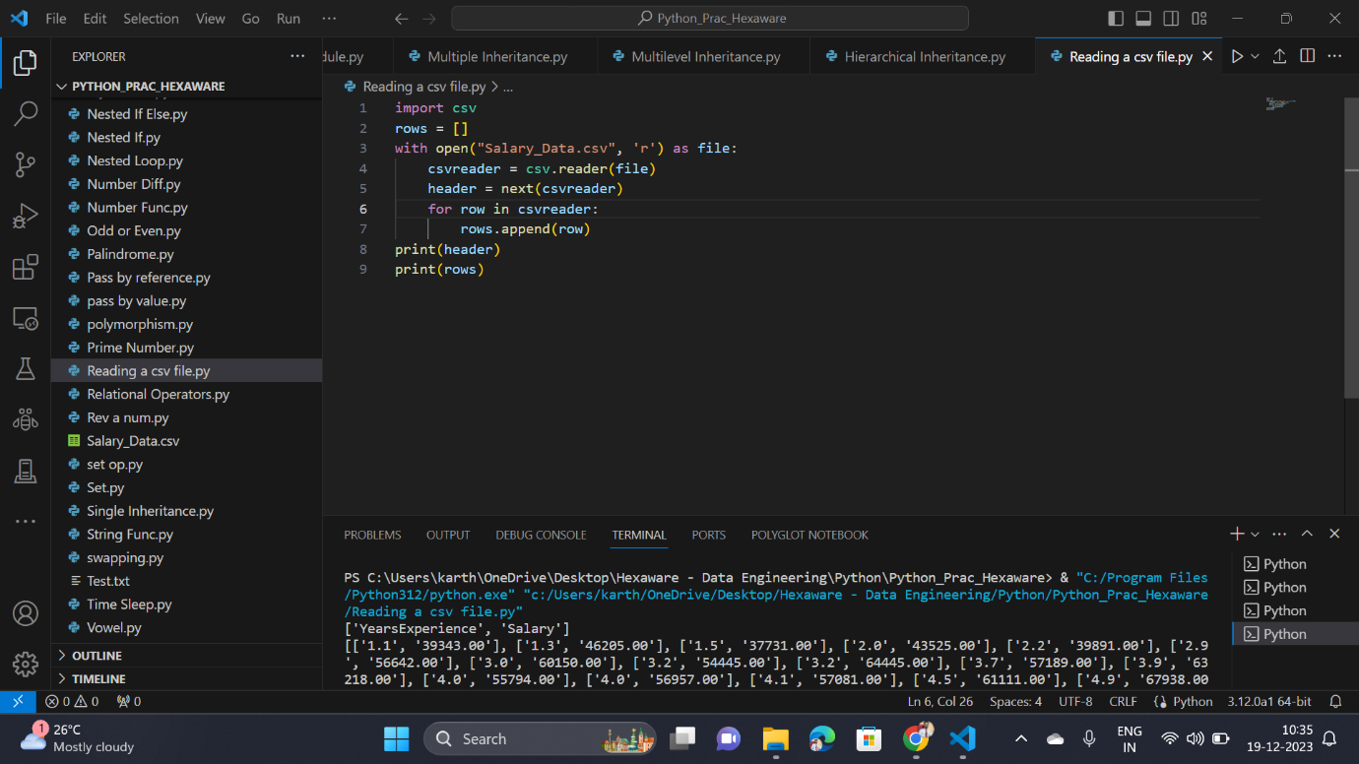

**Reading a data from csv file using panda’s library:**

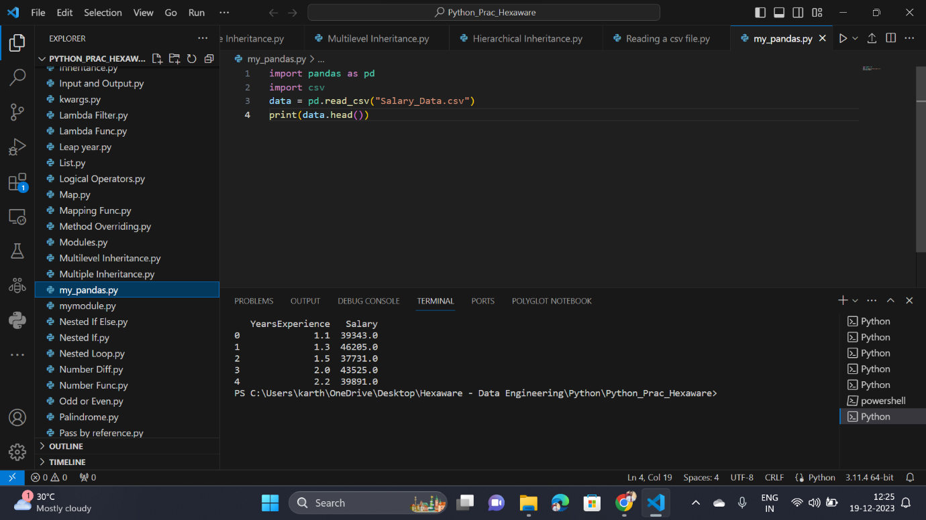

**Working with JSON:**

